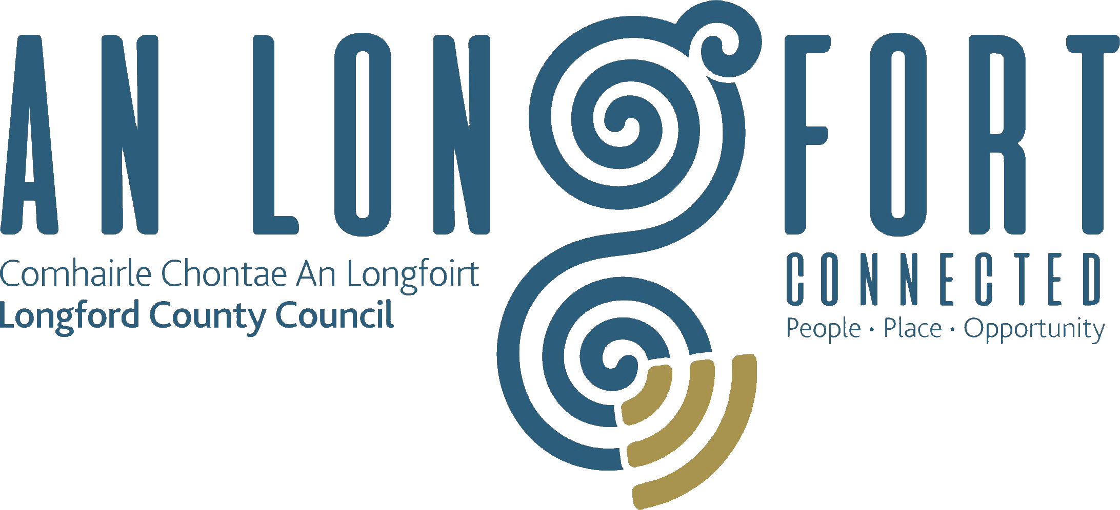

Minutes of Monthly Meeting of Longford County Council
held in the Council Chamber, Aras an Chontae, Great Water Street, Longford on
Wednesday, 13th June 2018 at 4.00 p.m.
____________________________________________________________________

PRESIDING: Councillor Martin Mulleady, Cathaoirleach.

MEMBERS PRESENT: Councillors – Paraic Brady, John Browne, Seamus Butler, Mick Cahill Micheál Carrigy, Mark Casey, Gerard Farrell,
Joe Flaherty, Gerard Hagan, Colm Murray, Peggy Nolan, Pat O’Toole, P.J. Reilly, Paul Ross, Mae Sexton and Gerry Warnock.

APOLOGIES: Councillor Luie McEntire

IN ATTENDANCE: Mr. Paddy Mahon, Chief Executive.
Mr. John McKeon, Head of Finance.
Ms. Barbara Heslin, Director of Services.
Mr. John Brannigan, Director of Services.
Mr. Ciaran Murphy, Senior Executive Officer.
Ms. Laura McPhillips, Administrative Officer.

MEETINGS
ADMINISTRATOR: Ms. Anne Lee.

SUSPENSION OF STANDING ORDERS.

Councillor P. Nolan proposed and Councillor M. Carrigy seconded that Standing Orders be suspended to allow for discussion regarding compensation for victims of the cervical cancer scandal.

On the proposal of Councillor P. Nolan seconded by Councillor M. Carrigy, it was unanimously agreed that an interim payment of €50,000 be made to the women and families affected by the cervical cancer misdiagnosis.

DRAFT INTERCULTURAL STRATEGIC PLAN FOR COUNTY LONGFORD – circulated.

Dr. Shelley Deane, Brehon Advisory, gave a comprehensive presentation regarding the Draft Intercultural Strategic Plan for County Longford and replied to queries raised by the members.

A number of issues were raised by the members, including the need for a specially dedicated Integration Office.

Dr. Deane agreed to engage with any members of the Council who wish to discuss the Draft Strategy further with her.

It was agreed that adoption of the Draft Plan be deferred to a further meeting of the Council.

ADOPTION OF MINUTES.

On the proposal of Councillor P. Brady seconded by Councillor P. Nolan , the Minutes of Monthly Meeting of Longford County Council held on the 9th May 2018, as circulated, were confirmed and adopted.

MATTERS ARISING FROM MINUTES.

None.

CHIEF EXECUTIVE ORDERS.

The Chief Executive Orders, as circulated, were noted.

MONTHLY MANAGEMENT REPORT.

The Monthly Management Report, as circulated, was noted.

CORPORATE POLICY GROUP MINUTES.

The adopted Minutes of Corporate Policy Group Meeting held on the
11th April 2018, as circulated, were noted.

ECONOMIC AND COMMUNITY DEVELOPMENT, PLANNING, HUMAN RESOURCES & CORPORATE SERVICES, CULTURAL & RECREATIONAL SERVICES.

Planning Applications.

The list of Planning Applications received since May meeting of the Council was noted.

Minutes of Planning and Development and Cultural Strategic Policy Committee Meeting.

The adopted minutes of Planning and Development and Cultural Strategic Policy
Committee Meeting held on the 19th February 2018, as circulated, were noted.

Minutes of Economic Development and Enterprise Strategic Policy Committee.

The adopted minutes of Economic Development and Enterprise Strategic Policy
Committee Meeting held on the 12th February 2018, as circulated, were noted.

Recommendation from Planning and Development and Cultural Strategic Policy Committee –

On the proposal of Councillor G. Warnock seconded by Councillor P.J. Reilly, the following recommendation from the Planning and Development and Cultural Strategic Policy Committee was agreed -

“That Longford County Council requests Irish Water to receive a deputation from Longford
County Council regarding Irish Water Capital Plan for Ballymahon and Edgeworthstown.

Membership of Longford Local Community Development Committee (LCDC).

On the proposal of Councillor S. Butler seconded by Councillor P. Brady, it was unanimously agreed that Ms. Anne Naughton, nominee of Health Service Executive, replace Ms. Grainne nic Gabhann as a member of Longford Local Community Development
Committee (LCDC).

Variation No. 4 of the Longford County Development Plan 2015-2021.

On the proposal of Councillor G. Farrell seconded by Councillor M. Cahill, it was unanimously agreed to adopt Variation No. 4 of the Longford County Development Plan 2015-2021, as circulated.

2017 Annual Report.

On the proposal of Councillor M. Cahill seconded by Councillor J. Browne, it was unanimously agreed to adopt 2017 Annual Report, as circulated.

Civic Receptions.

On the proposal of Councillor S. Butler seconded by Councillor P. Nolan, it was unanimously agreed that Civic Receptions, as approved by the Corporate Policy Group,
be held as follows -

- St. Mel’s Musical Society - 21st June 2018.
- Ballinamuck Twinning - 27th July 2018.

HOUSING, INFRASTRUCTURE, ENVIRONMENT & EMERGENCY SERVICES.

Minutes of Housing Services Strategic Policy Committee Meeting.

The adopted Minutes of Housing Services Strategic Policy Committee Meeting held on the 13th February 2018, as circulated, were noted.

Longford County Council – Local Authority Deposit Scheme.

On the proposal of Councillor S. Butler seconded by Councillor M. Carrigy, it was unanimously agreed to adopt Longford County Council – Local Authority Deposit Scheme,
as circulated.

Section 85 Agreement.

On the proposal of Councillor Seamus Butler seconded by Councillor Michael Carrigy, it was unanimously agreed to approve Agreement between Longford County Council and Kildare County Council in accordance with Section 85 of the Local Government Act 2001, for the TII Lenister Bridges Rehabilitation Contract 2018 within the Administrative Area of Longford County Council, as circulated.

OPW Flood Risk Management Plan.

On the proposal of Councillor M. Carrigy seconded by Councillor S. Butler, it was unanimously agreed to adopt OPW Flood Risk Management Plan.

Notices of Motions,

Improvement Works in Housing Estates.

The following Notice of Motion was proposed by Councillor J. Flaherty and seconded by Councillor M. Cahill -

“I request that Longford County Council undertakes an audit and based on the findings compile an action plan to carry out improvement works in all estates built more than twenty
years ago.”

J. Brannigan stated that the Council are currently recruiting additional staff in the housing section. When the staff are in place, survey works can commence on the housing stock.
A priority list of works will then be compiled and subject to funding will be completed.

Fines for Illegal Dumping.

The following Notice of Motion was proposed by Councillor P. Brady and seconded by Councillor M. Carrigy -

“That Longford County Council increases the fine from €1,500 to €5,000 for anyone dumping illegally and that these people will be named and shamed and that Longford County
Council erects more cameras in the hot spots where illegal dumping has taken place

J. Brannigan stated that the Litter Pollution Act 1997 provides for penalties for people who litter it is not at the discretion of an individual Local Authority. Leaving or throwing litter in a public place is an offence that can be subject to an on-the-spot fine of €150, or a maximum fine of €3,000 if you are convicted in the District Court. Where an offence continues after conviction, the person concerned is guilty of a further offence and liable to a fine not exceeding €600 for each day during which the contravention continues. The Protection of the Environment Act 2003 introduced conviction on indictment and carries a maximum fine not exceeding €130,000 and a fine not exceeding €10,000 per day for continuing offences.

Councillor P. Brady stated that fines should be deducted from the offenders’ source of income.

FINANCE & INFORMATION SYSTEMS.

Public Liability Claims.

It was noted that two Public Liability Claims were received during May 2018.
Local Government Funding (Baseline) Review .

J. McKeon gave a comprehensive presentation regarding the Local Government Funding (Baseline) Review and informed the members that the consultation process is open until
3rd July 2018. John confirmed that submissions are welcome from the members.

It was agreed that a submission be prepared on behalf of Longford County Council.

Notice of Motion.

Rates Bands.

The following Notice of Motion was proposed by Councillor M. Carrigy and seconded by Councillor P. Brady -

“I call on the Minister for Housing Planning and Local Government to introduce legislation which will allow Local Authorities introduce different rates bands in their various districts to help stimulate increased start ups and help business who are finding it difficult to survive.”

It was agreed that a letter be forwarded to the Minister for Housing, Planning and Local Government.

Promotion Boards.

Councillor P. Nolan proposed and Councillor M. Carrigy seconded that Promotion Boards be erected on the approach roads into Longford Town highlighting “brands” which are available in retail outlets in Longford town. Councillor Nolan’s request to be investigated.

Part 8 Planning – Longford Digi-hub.

Councillor M. Sexton proposed and Councillor M. Carrigy seconded that the Part 8 planning process be re-advertised for the proposed Digi-hub in the former Providers Building.

GENERAL.

Correspondence – circulated.

Correspondence received from Deputy Robert Troy enclosing copy of Consumer Protection (Regulation of Credit Servicing Firms) (Amendment) Bill 2018 was noted.

Department of Housing, Planning & Local Government - Circular Letter LG 02/2018 – Training needs for elected members, was noted.

TRAINING.

Report from Corporate Policy Group was noted.

VOTE OF CONGRATULATIONS.

Councillor G. Hagan congratulated the Killoe Mens Shed winners of the Public Vote 2018 Topline Shed Series.

This concluded the business of the meeting.
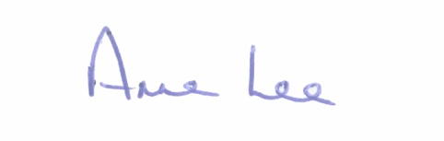

Signed: _______________
Anne Lee,
Meetings Administrator.

Confirmed and adopted at Monthly Meeting of Longford County Council held on the
11th July 2018.

Signed: _______________
Cathaoirleach.

